Yr 12 General Integrated Science
TASK 9 – Role of alcohol in car crashes

Research the relationship of alcohol consumption to the prevalence of car crashes. In your research discuss the effect of alcohol on the nervous system and how this can contribute to car crashes.

Outline some statistics from different states and territories on prevalence of car crashes and alcohol consumption as opposed to other factors contributing to car crashes.

Provide mathematical evidence of how alcohol can contribute to car crashes by describing how reaction distance is affected by alcohol consumption. Describe how total stopping distance is related to the reaction distance using a formula.

Outline what projects and campaigns are being launched by the State Government and other organisations to curb the incidence of car crashes related to alcohol consumption.

Describe how car crashes are impacting on our society, families, economy, insurance companies, etc…

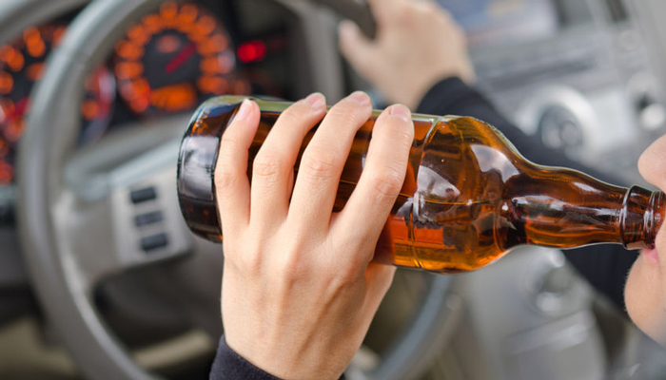

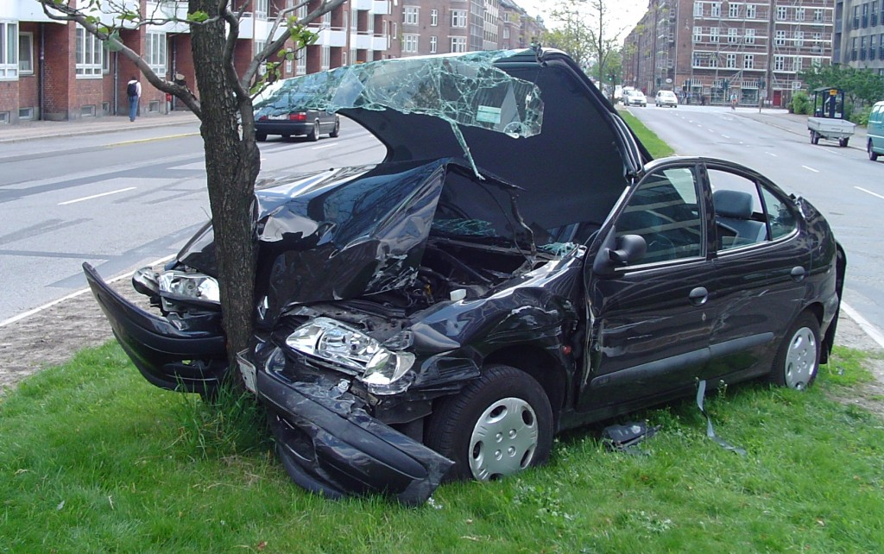

Due date: Friday 5 August – Week 3 Term 3.

